

Muhammad Haris Ali
Fa21-Bse-135
Section B
Mid Lab Exam
Mam Yella Mehroz

Scenario
A company is developing an online food delivery app. The Product Owner gathers requirements and creates a Product Backlog. The team plans a two week sprint to develop important features. First is to build the user login and restaurant listing. Developers work on coding, and testers validate the features. A bug is found in the payment system and logged for fixing. The Scrum Master removes blockers and ensures smooth progress. The team holds daily meetings to discuss updates. At the end of the sprint, a Sprint Review is conducted.
Board:

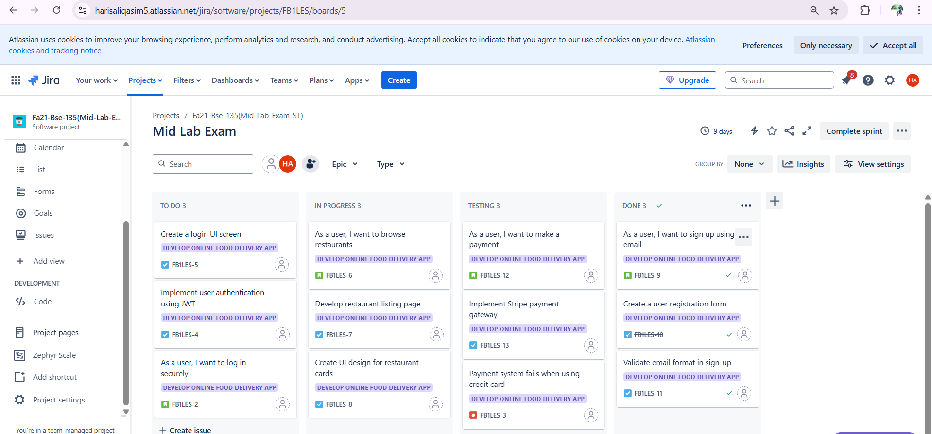
Timeline:
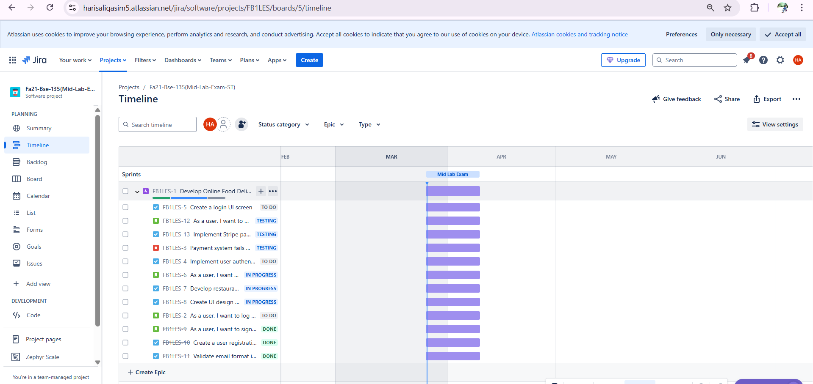

Backlog:
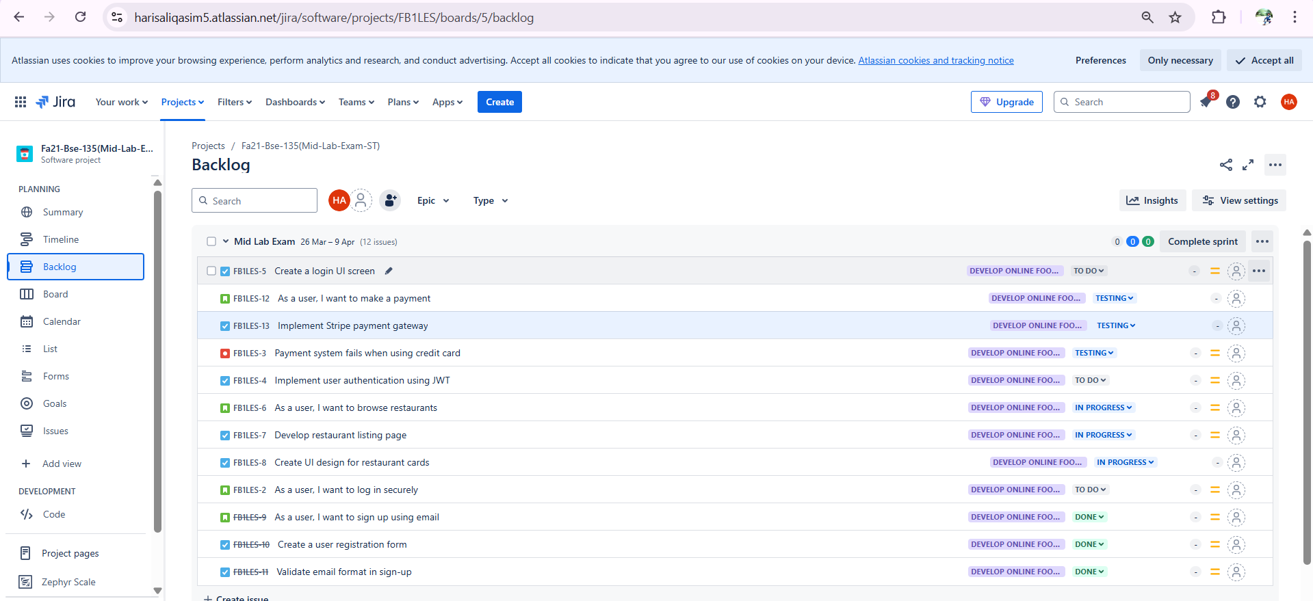
Workflow:

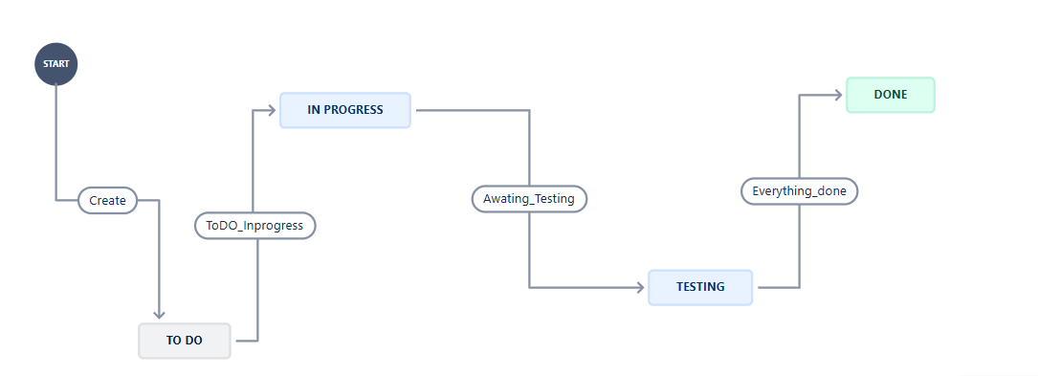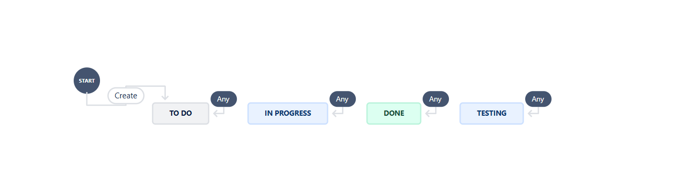
Setting Limit of Column:
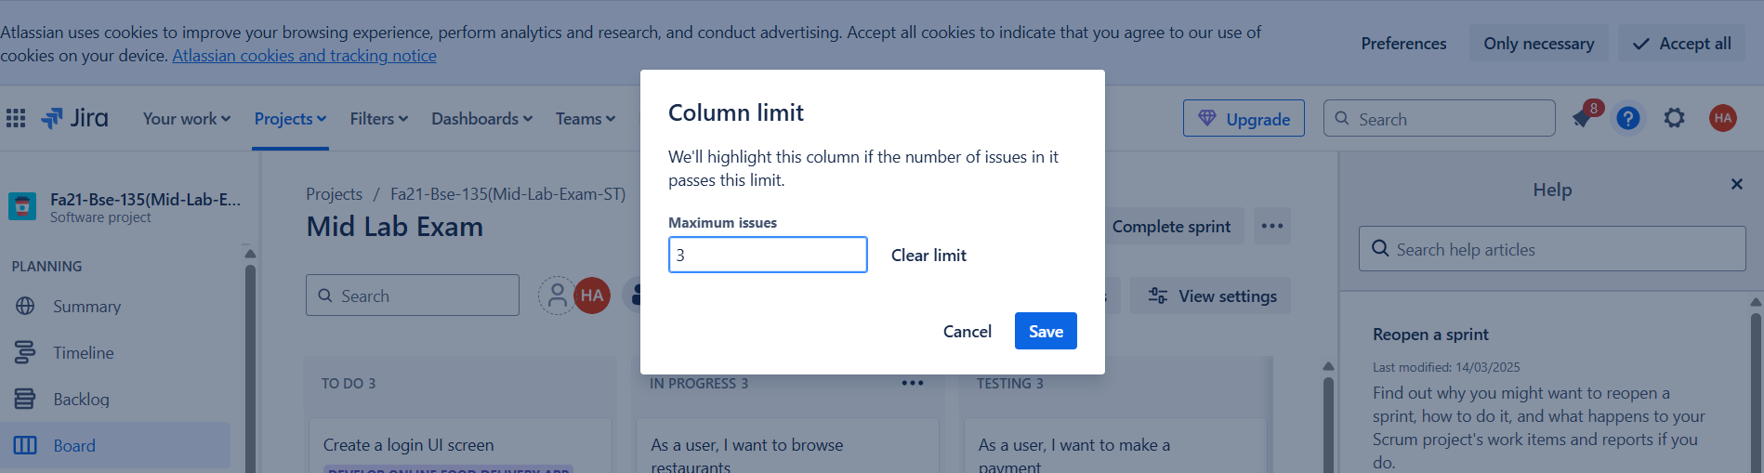
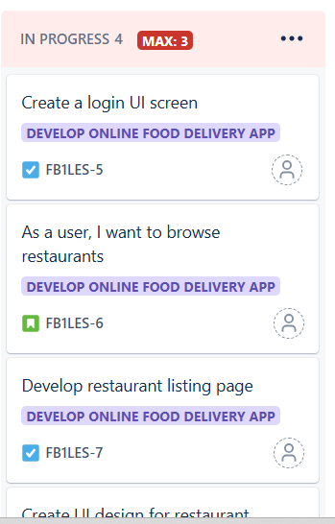
Limit is 3, but currently there is 4 tasks in progress so it indicates error
Automation Rules:

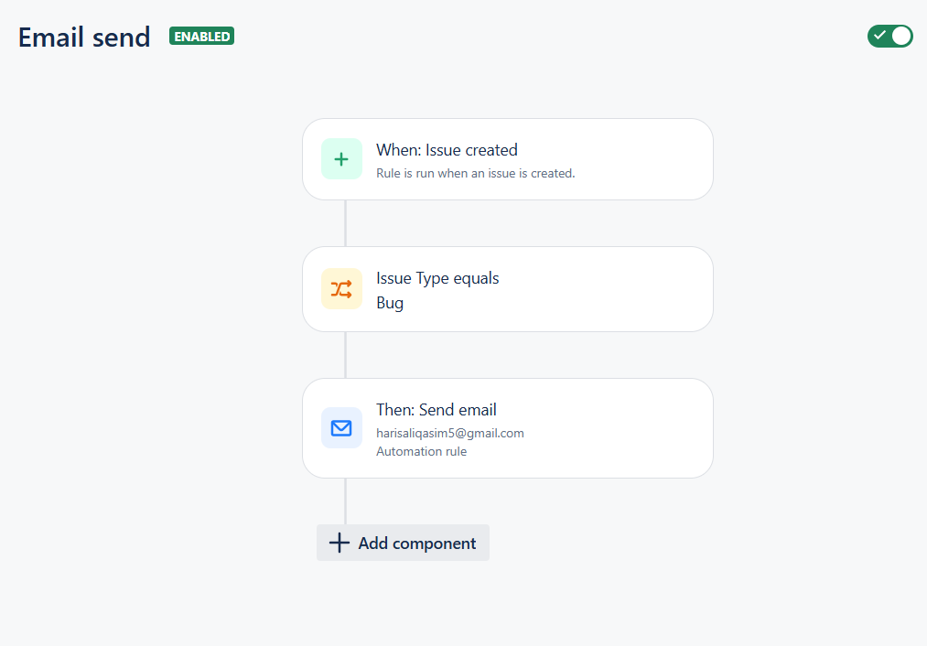
1)
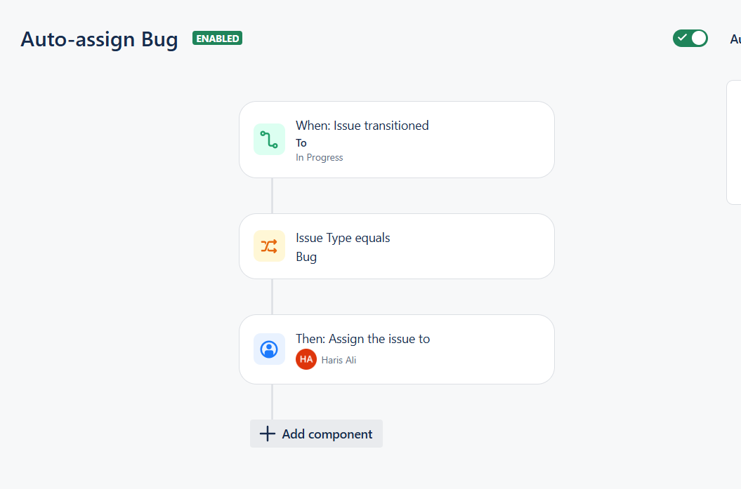
2)
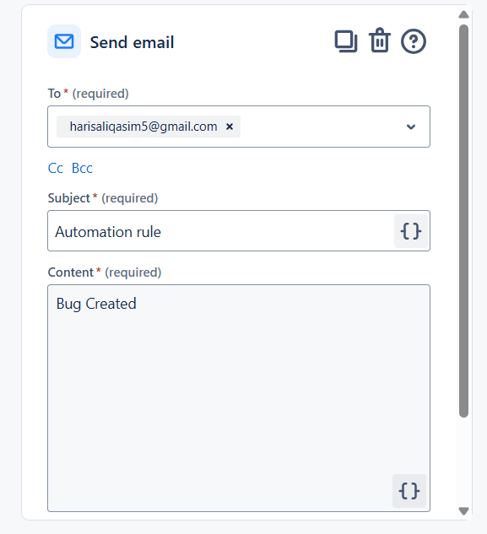
Email Received Successfully:
Custom Filters:
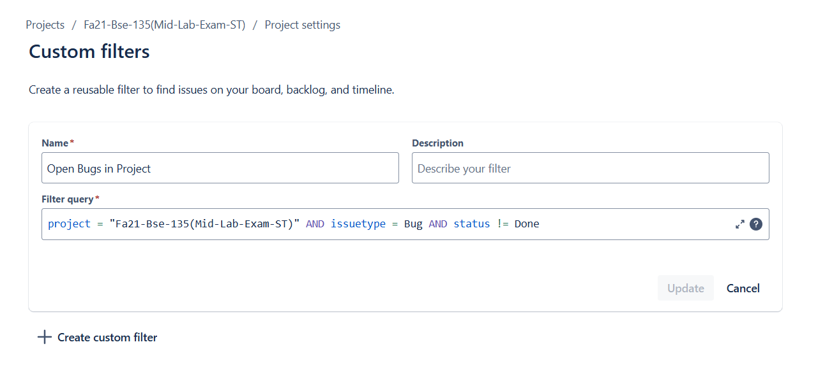
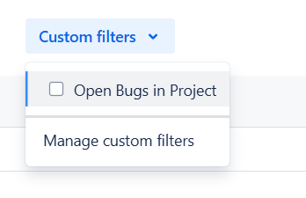
Application:
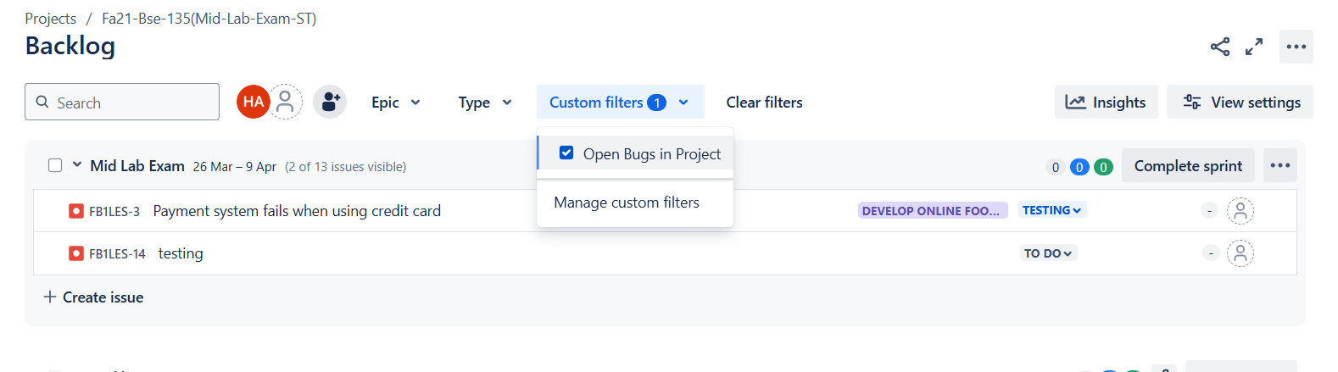
Dashboard:
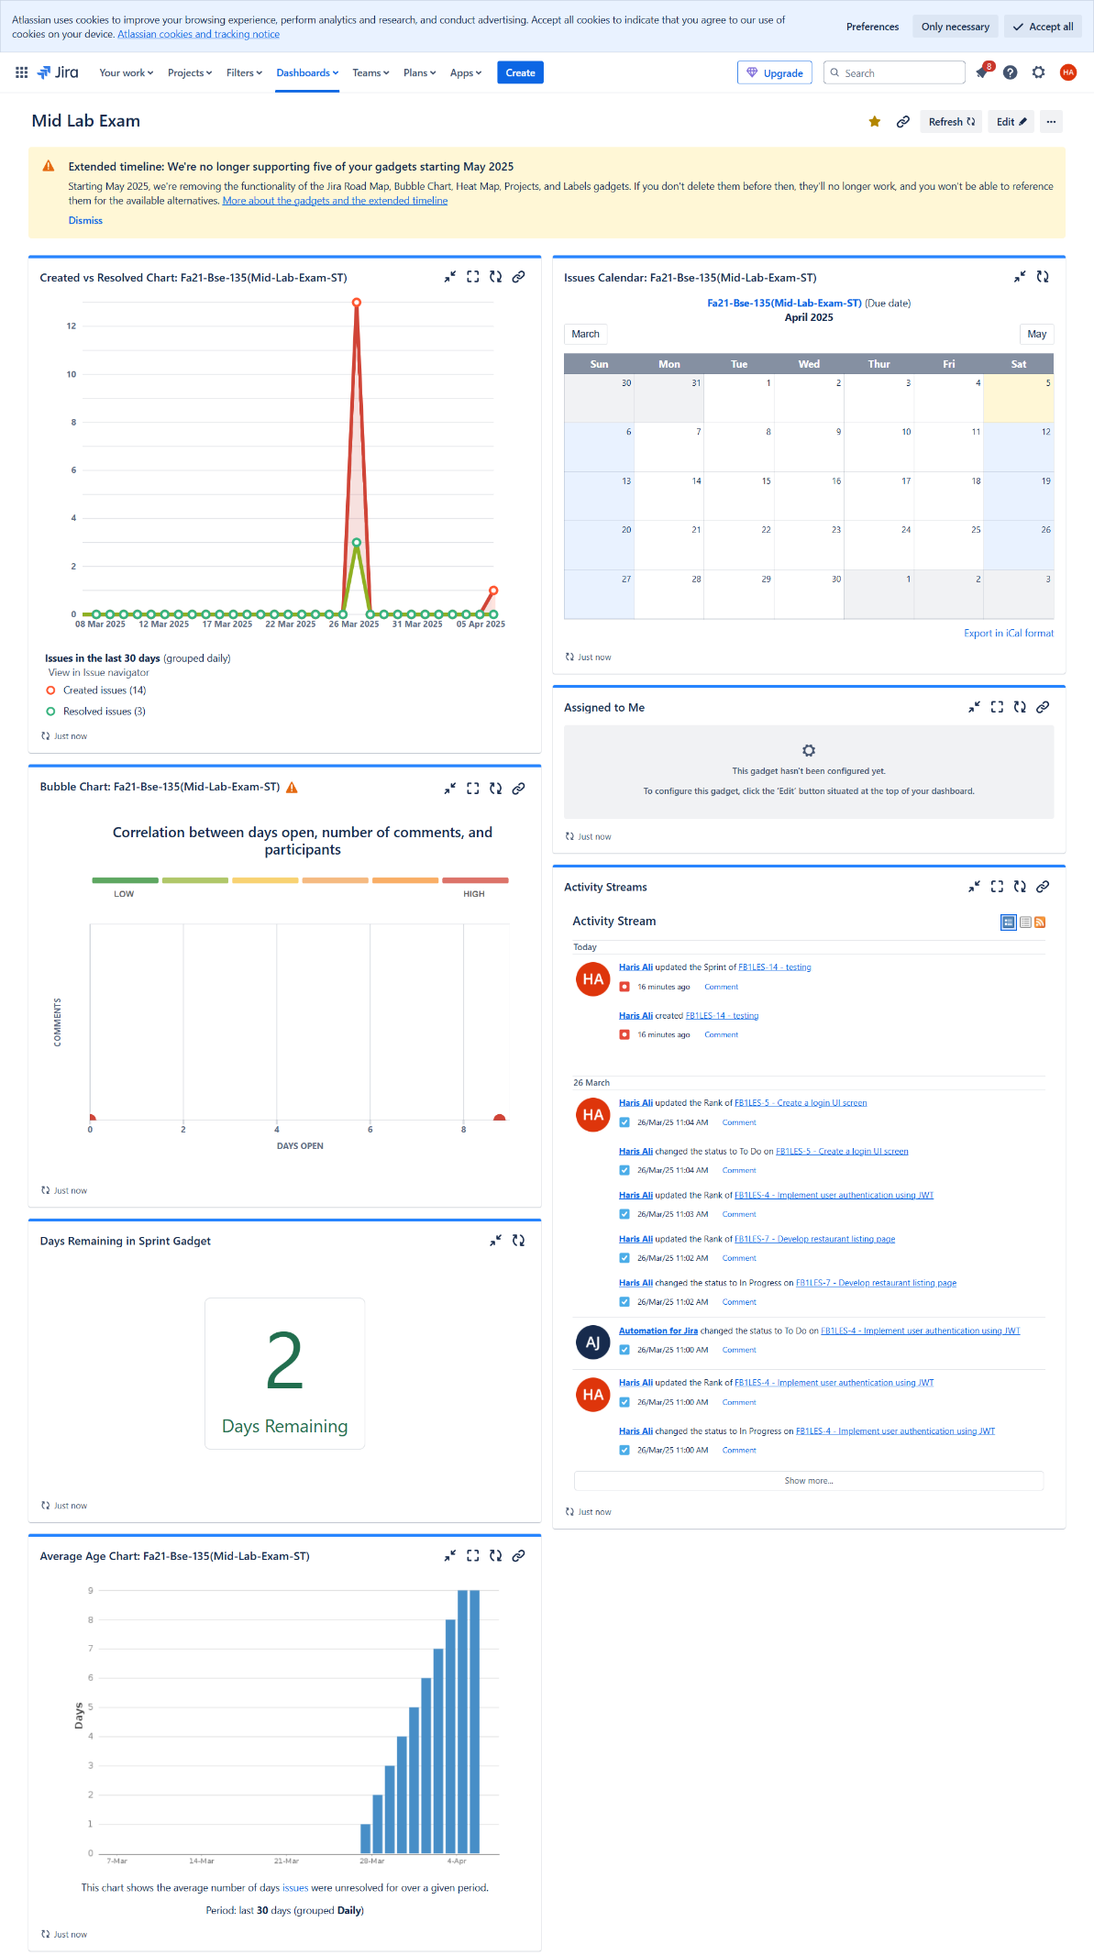
Test Cases
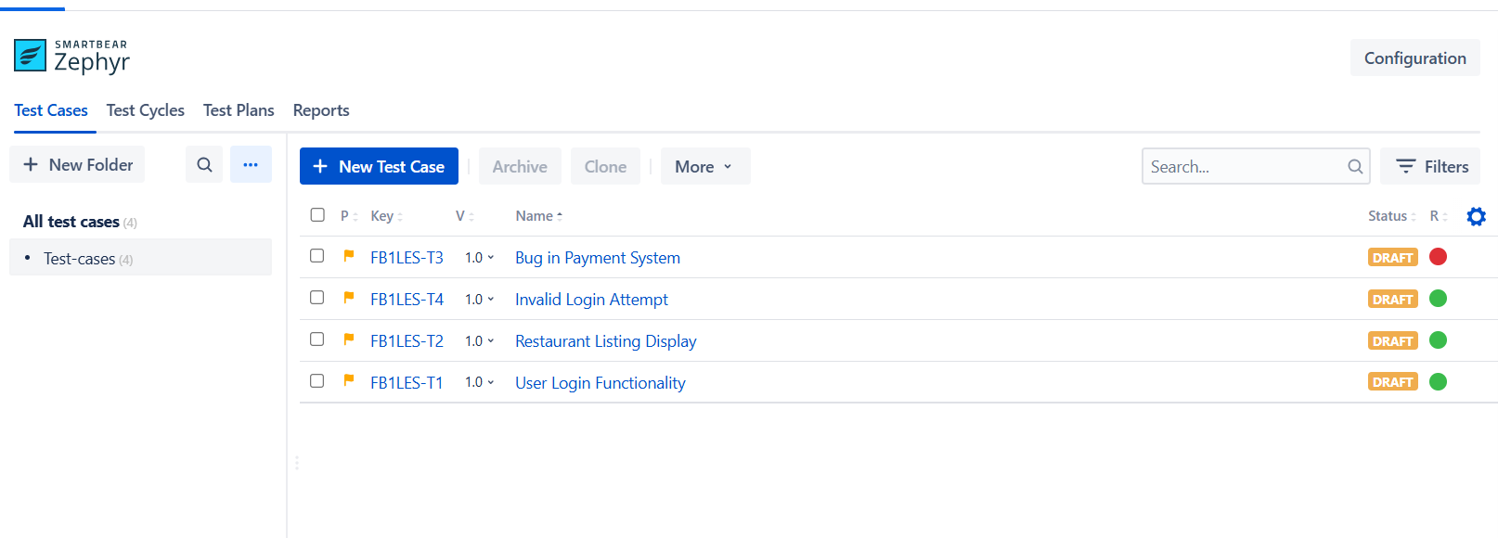
Test cases Script:
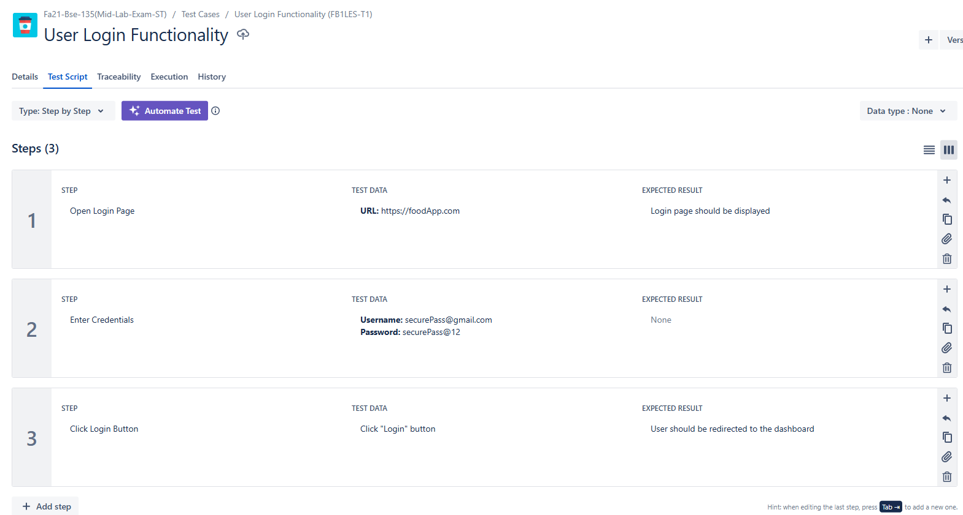
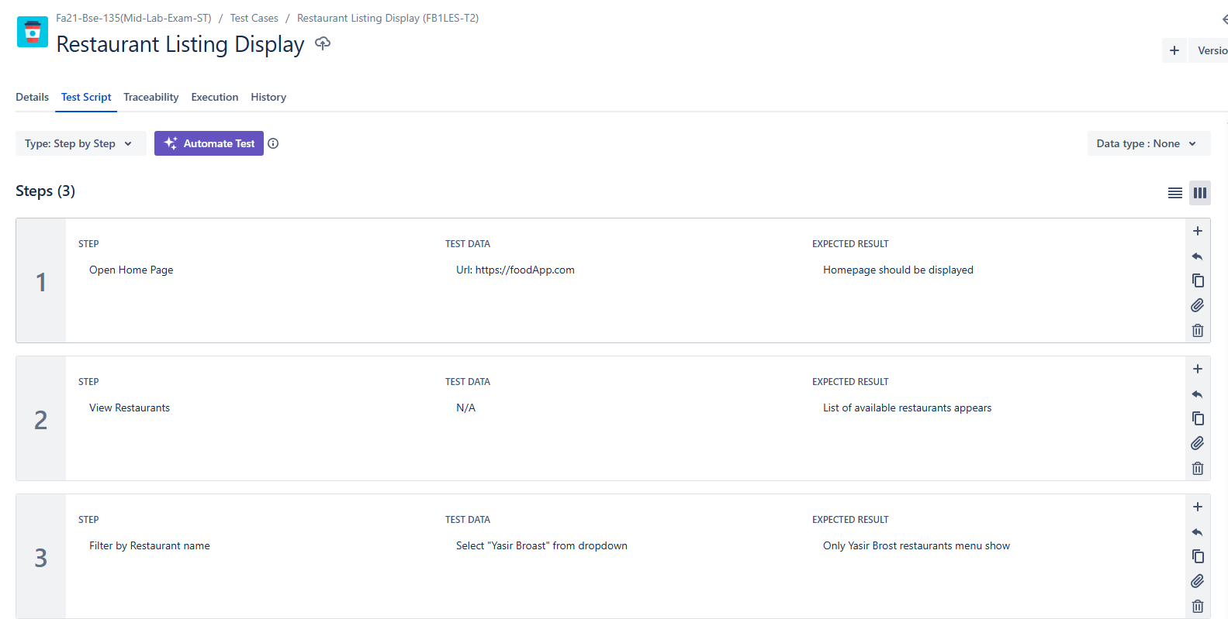
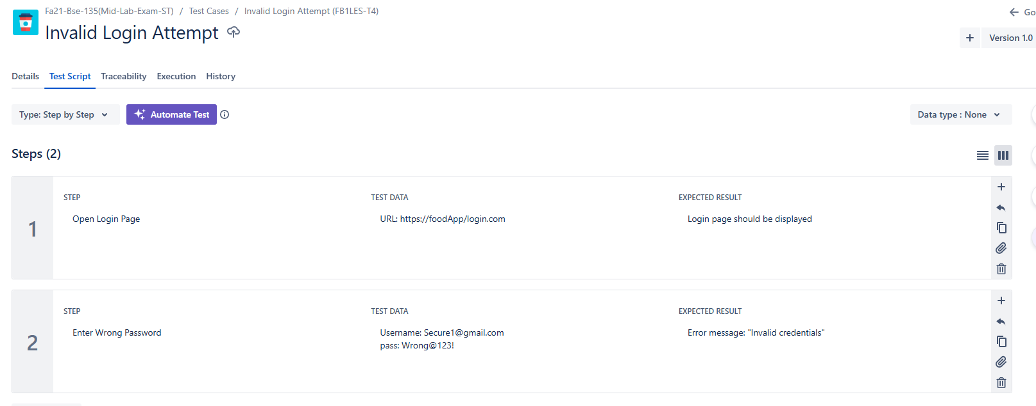
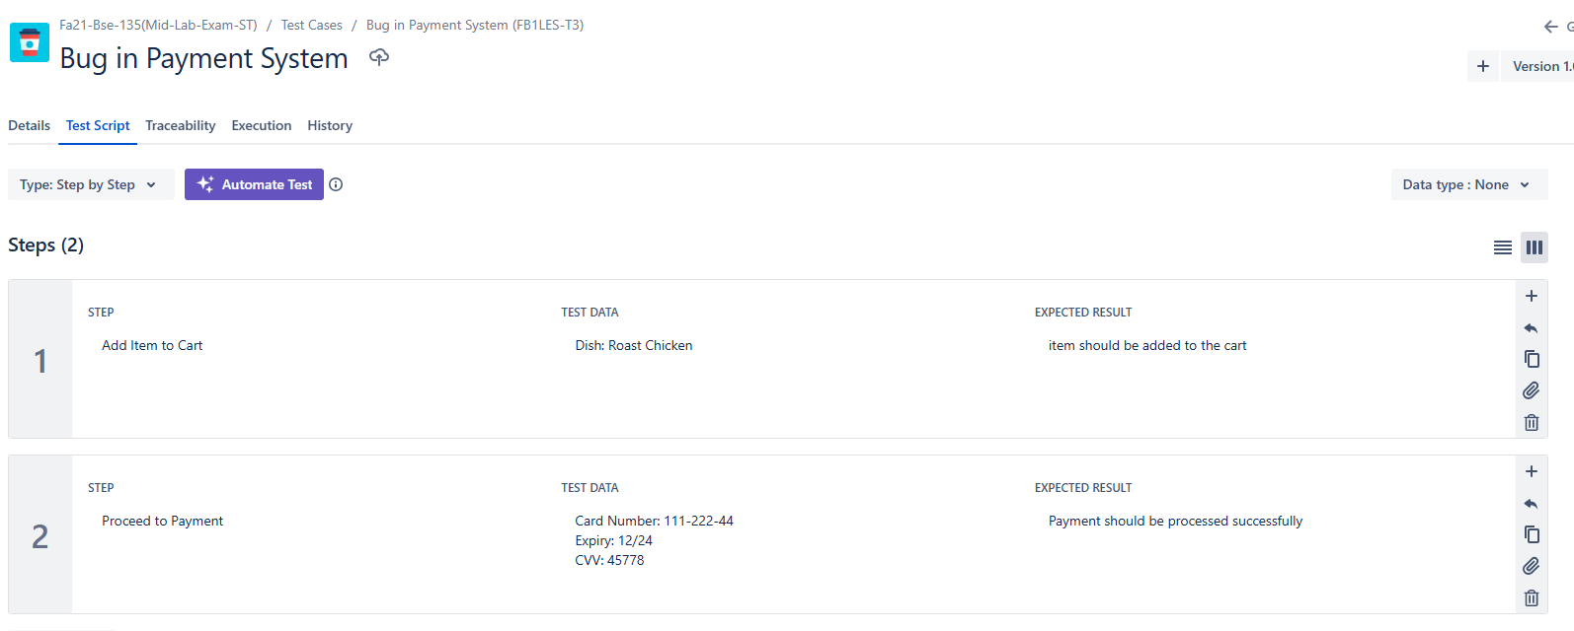
Test Cycles:
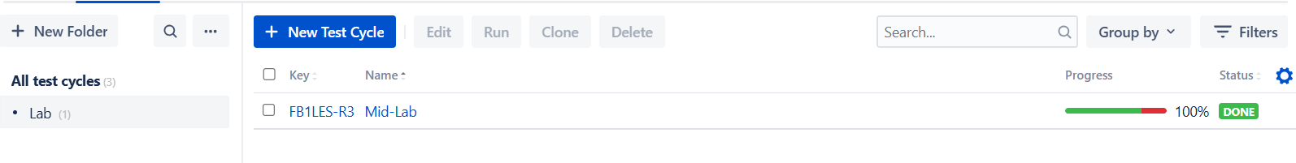
Test Cycle Execution:
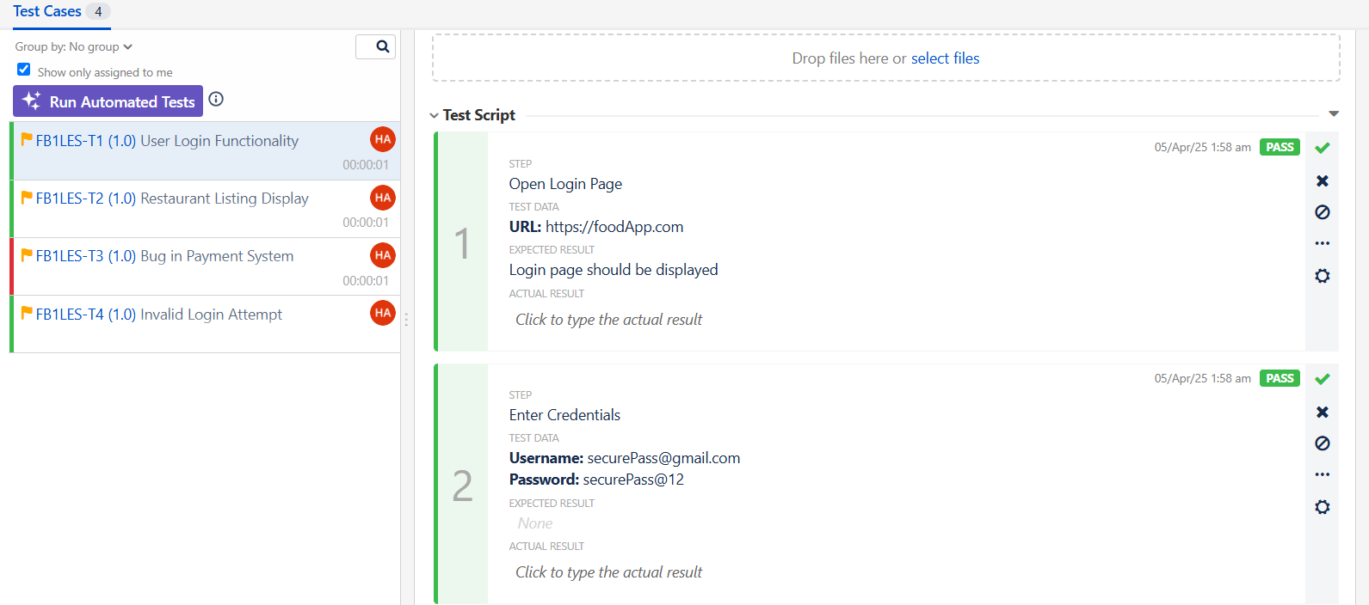
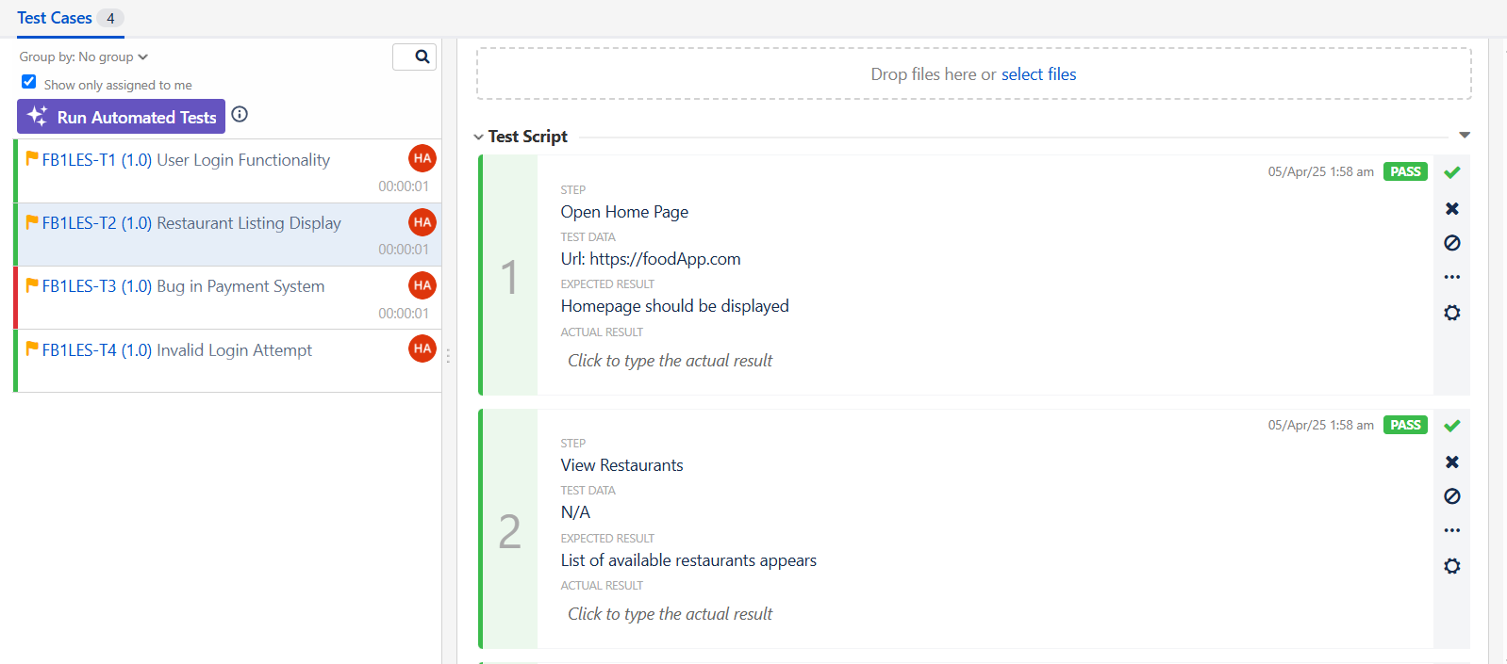
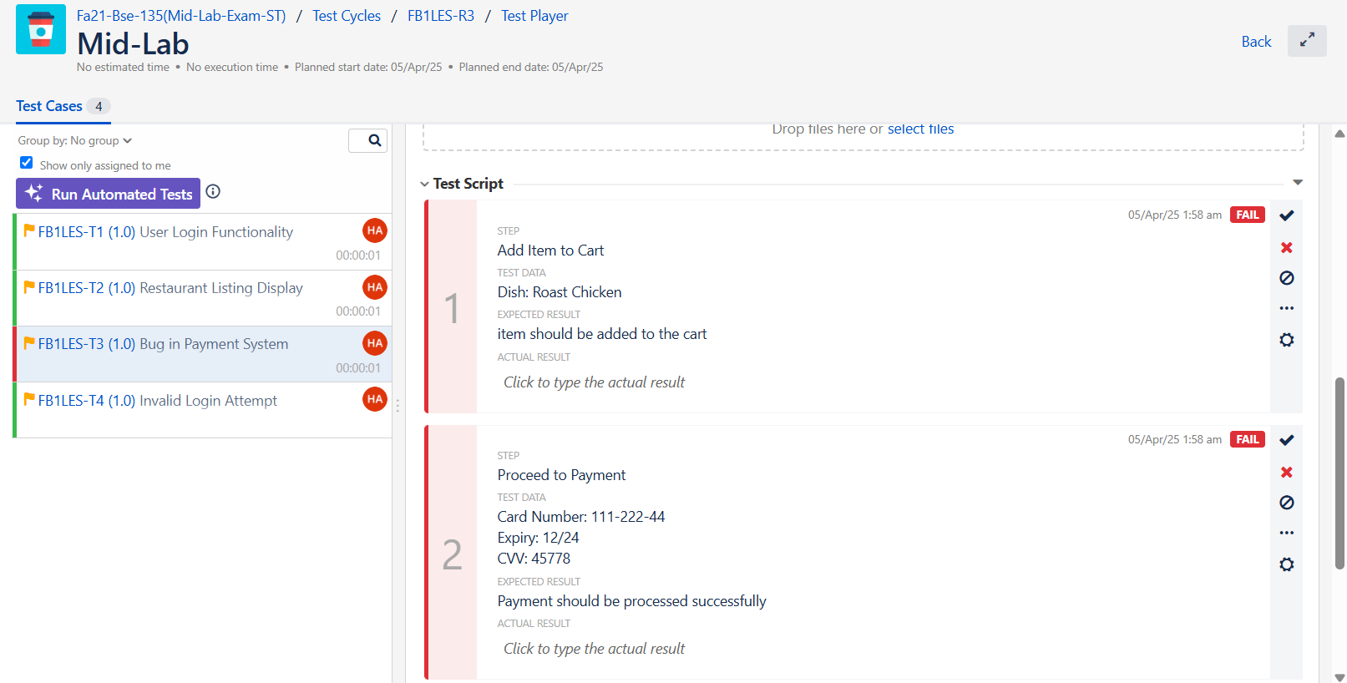
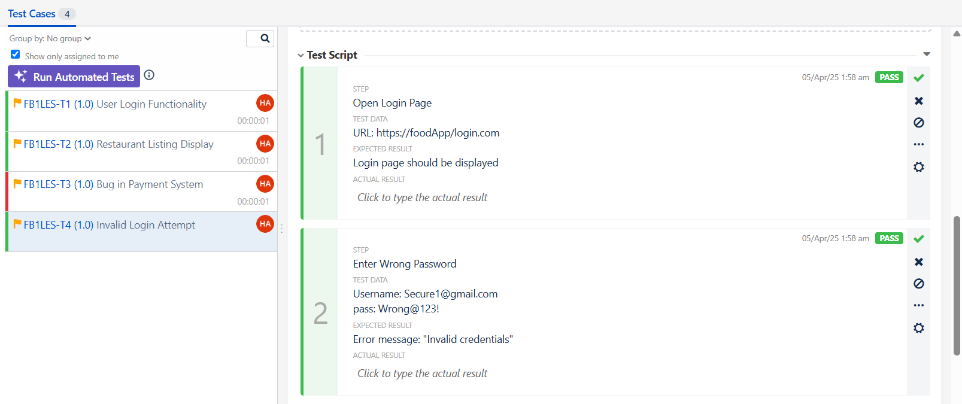
Traceability Report
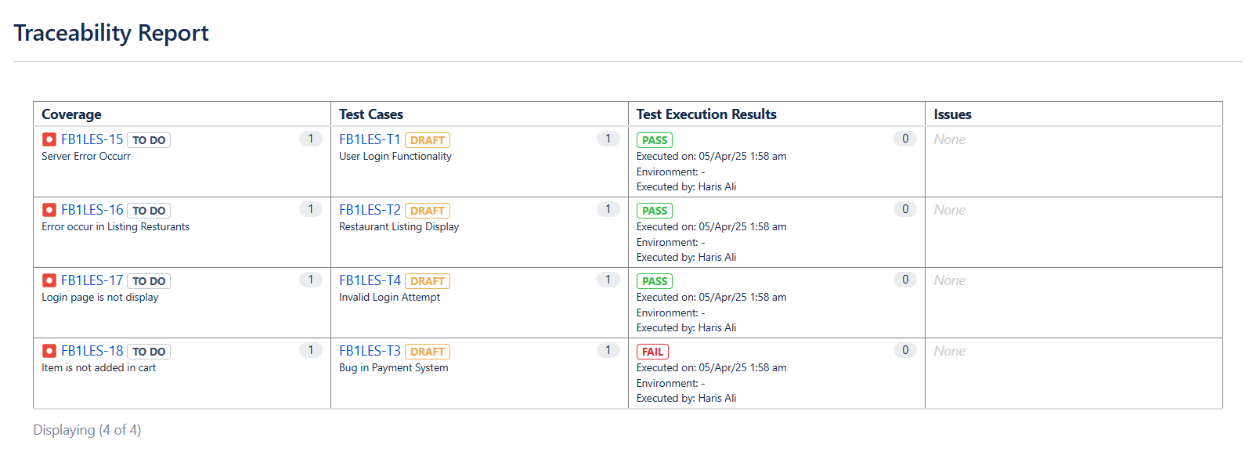
Other Reports

1)
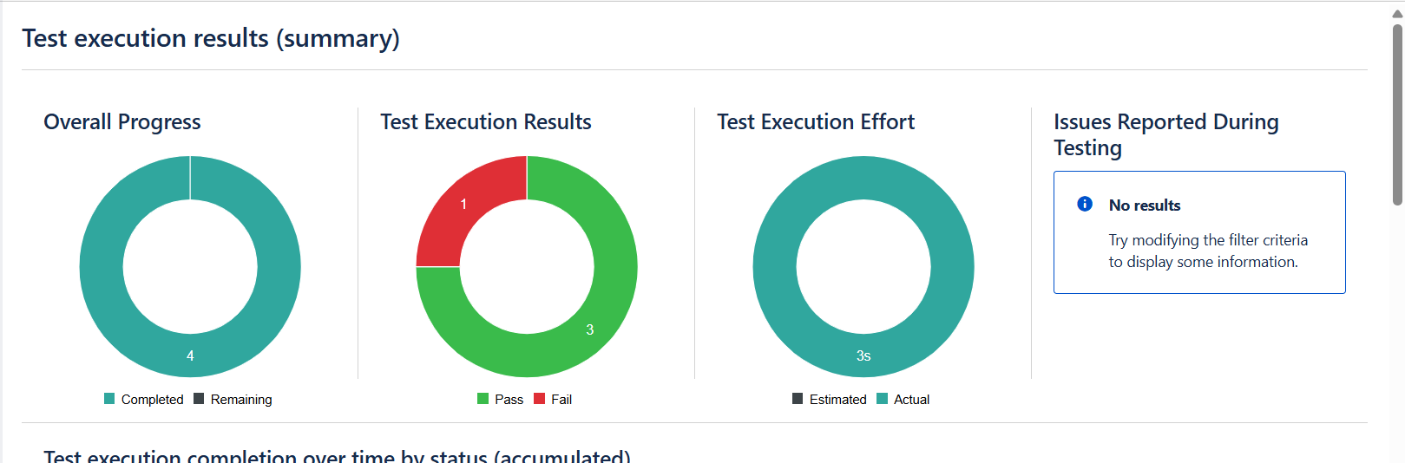

2)
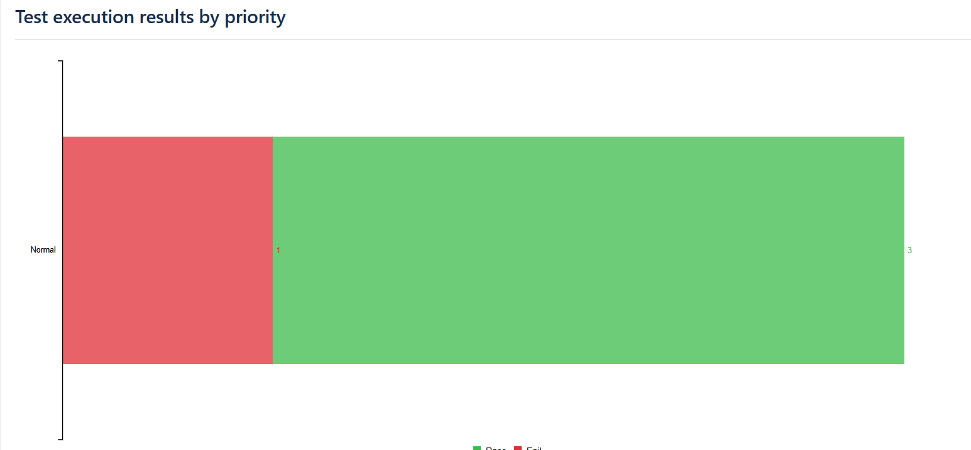

3)
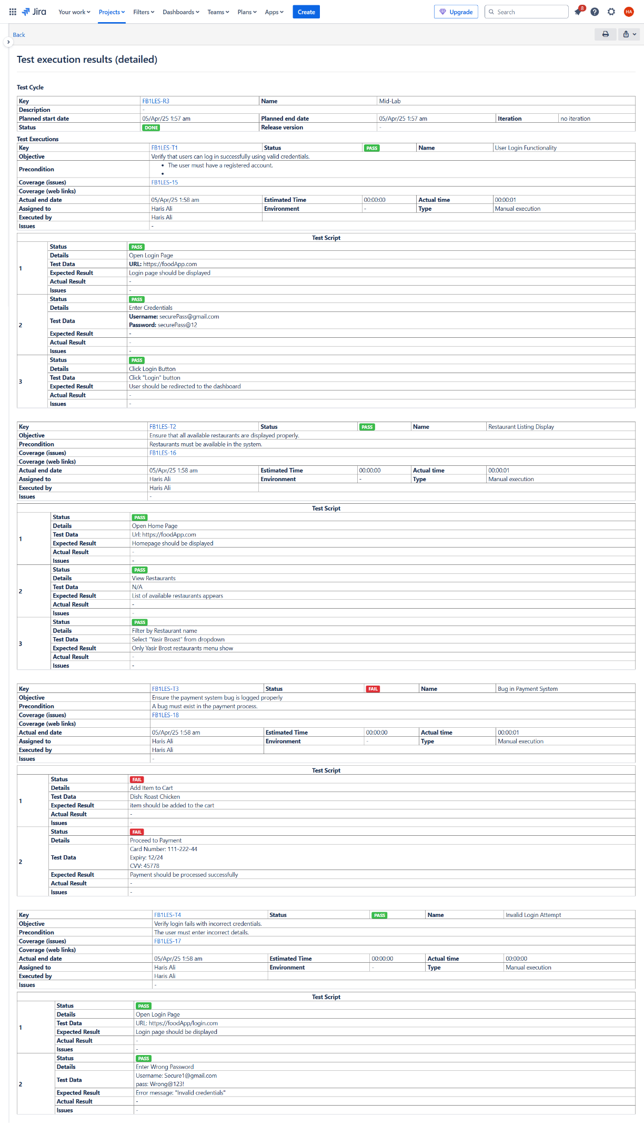
4)
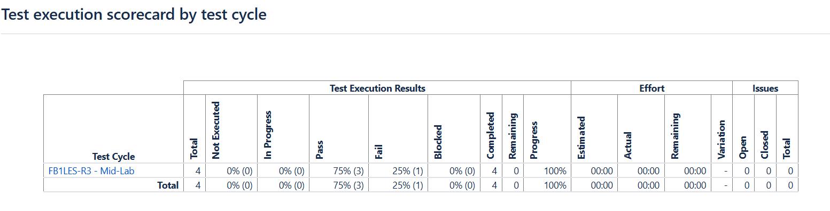
5)
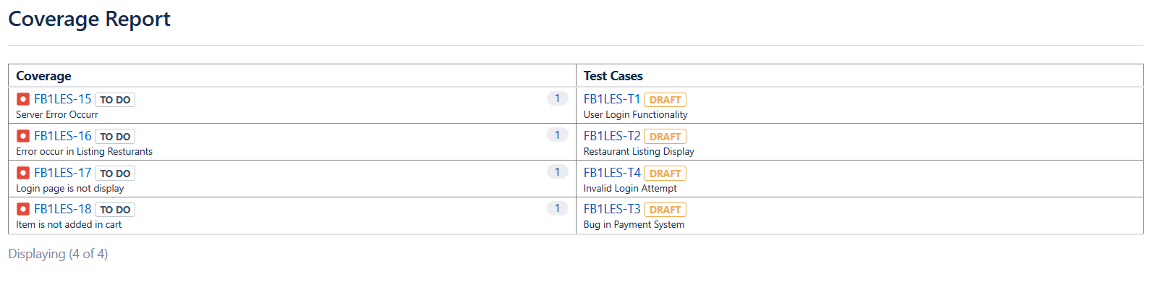
6)
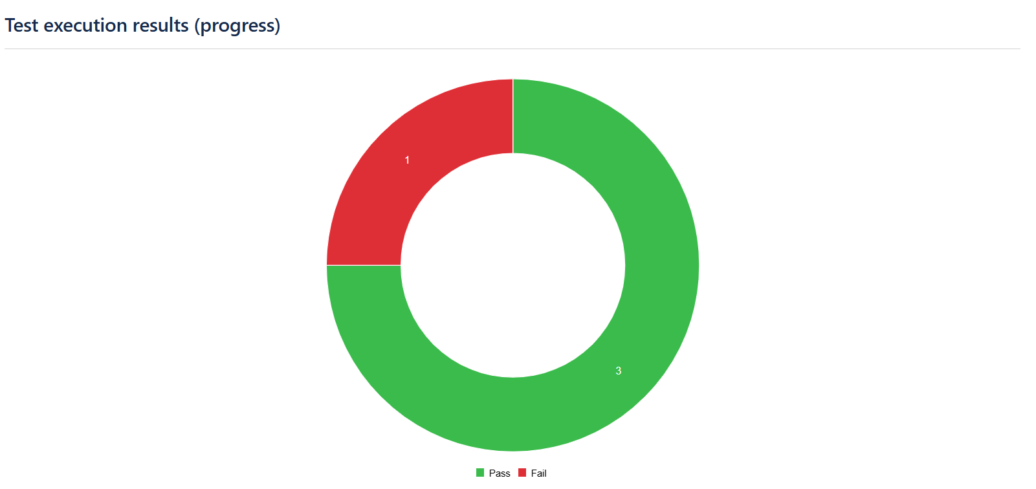
7)
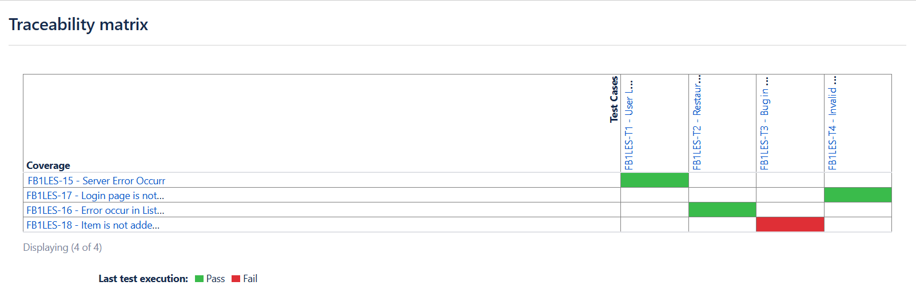
8)
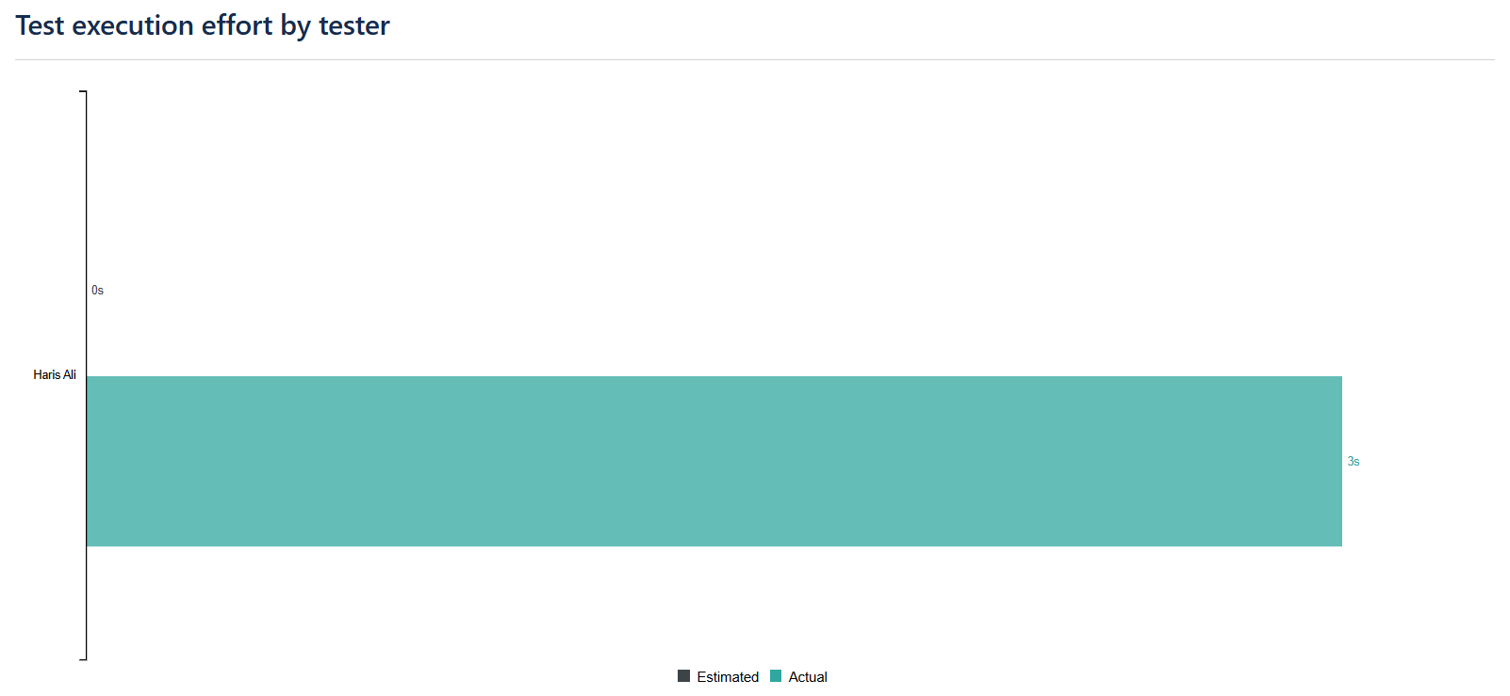

9)
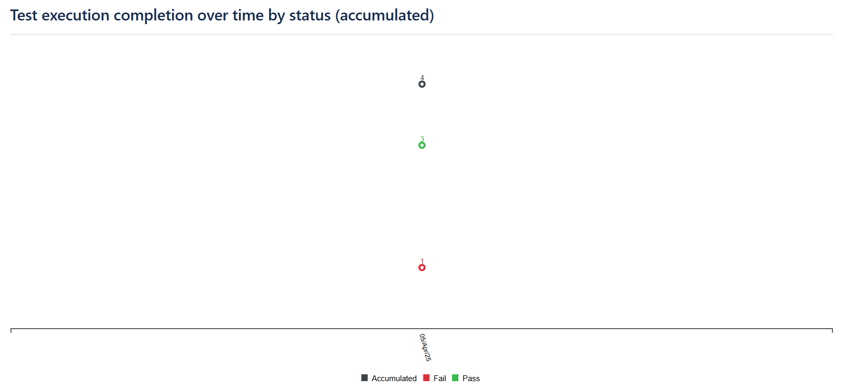
10)
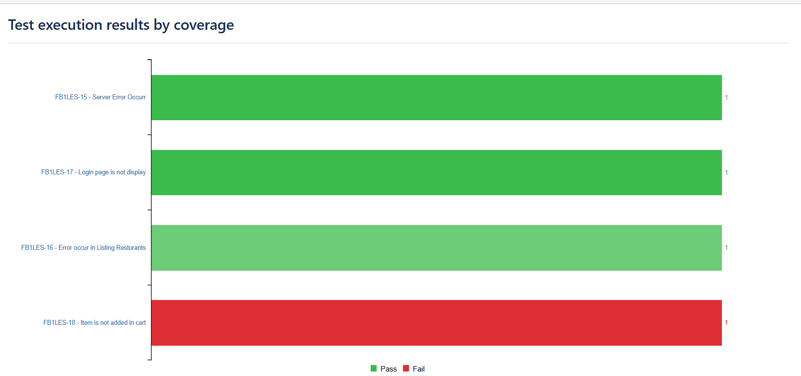
11)
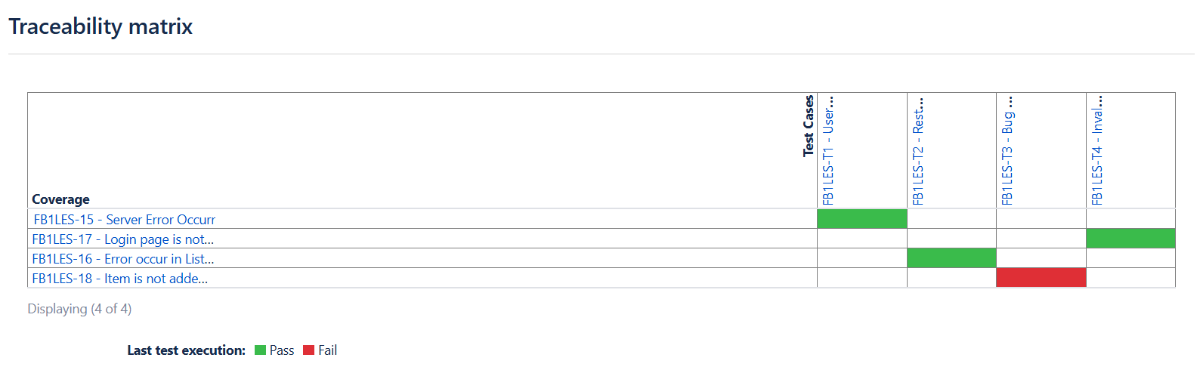
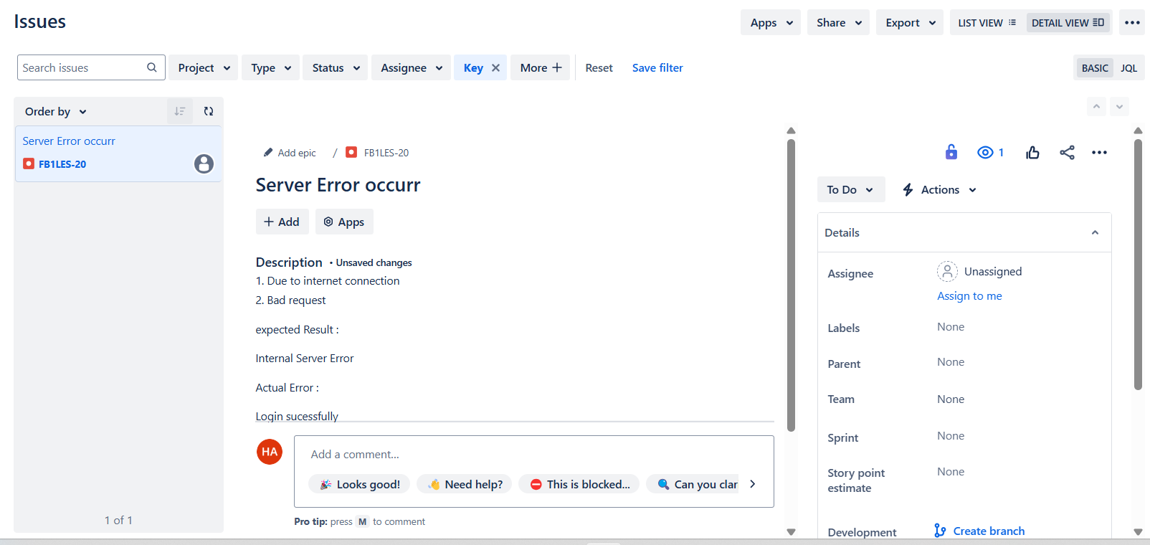

Confluence Report :
Muhammad Haris Ali --- Fa21-Bse-135

Scenario:
A company is developing an online food delivery app. The Product Owner gathers
requirements and creates a Product Backlog. The team plans a two week sprint to
develop important features. First is to build the user login and restaurant listing.
Developers work on coding, and testers validate the features. A bug is found in the
payment system and logged for fixing. The Scrum Master removes blockers and ensures
smooth progress. The team holds daily meetings to discuss updates. At the end of the
sprint, a Sprint Review is conducted.
Objectives:
• Understand and apply Scrum methodology in software development.
• Create and manage a Product Backlog based on gathered requirements.
• Plan and execute a two-week sprint to develop core features.
• Implement and test user login and restaurant listing functionality.
• Identify, log, and track bugs during development (e.g., payment system issue).
• Ensure continuous progress by removing blockers through the Scrum Master.
• Conduct daily stand-up meetings to share progress and resolve issues.
• Perform a Sprint Review to demonstrate completed work and gather feedback.
• Encourage collaboration among team members (Product Owner, Developers, Testers, Scrum Master).
• Reflect on the sprint to improve future planning and execution.
Bug Link:
FB1LES-15 - Server Error Occurr To Do
Story Link:
FB1LES-4 - Implement user authentication using JWT To Do
Timeline:
https://harisaliqasim5.atlassian.net/jira/software/projects/FB1LES/boards/5/timeline

Git Connectivity
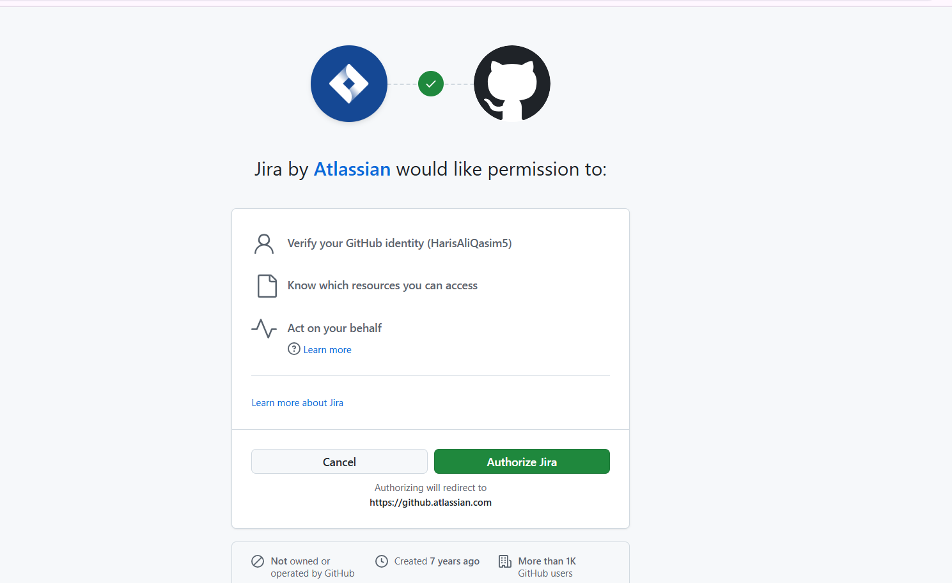
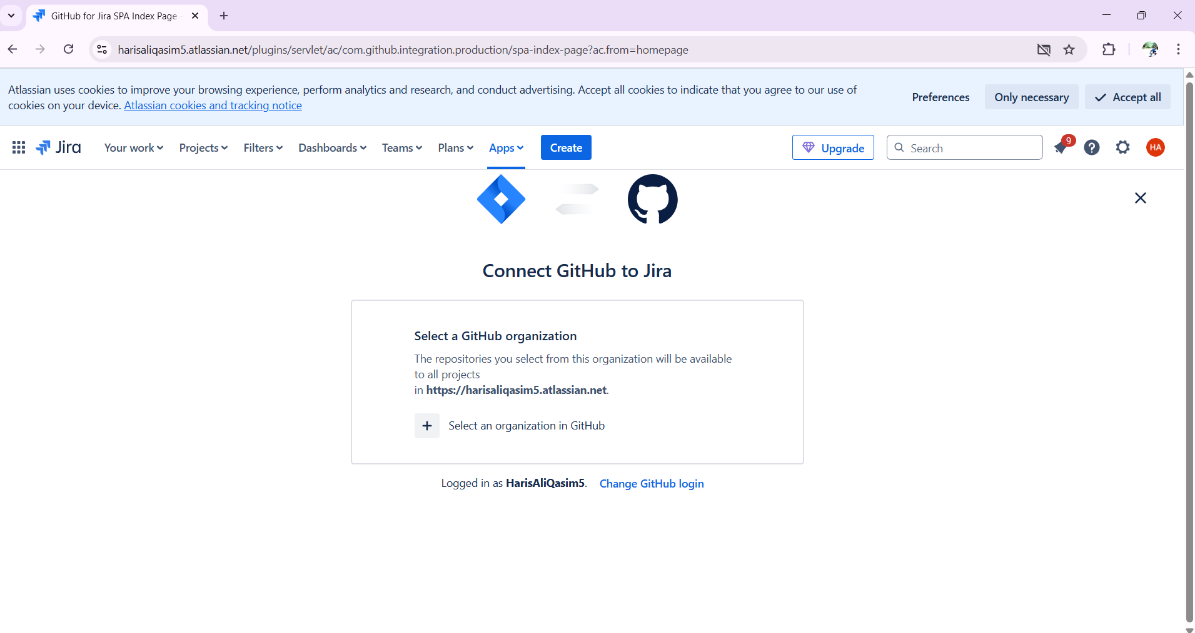
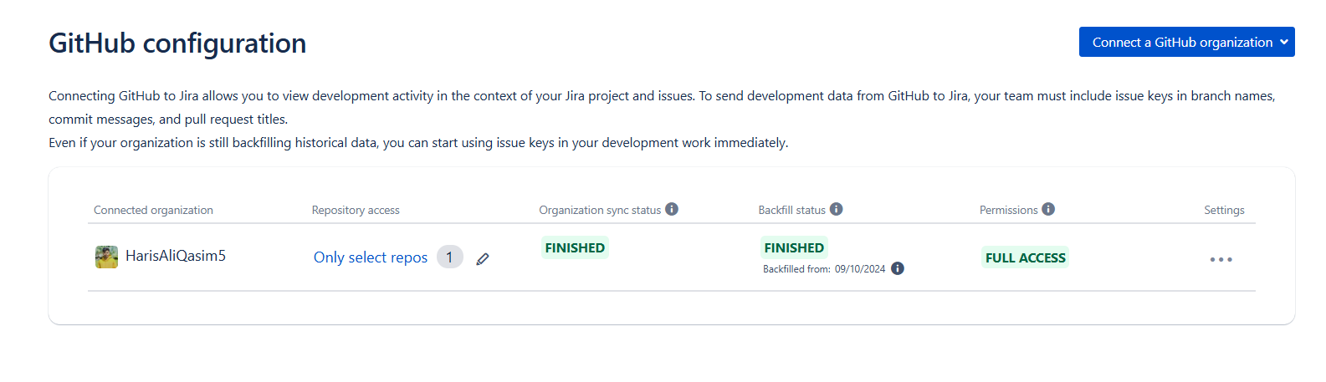

Figma
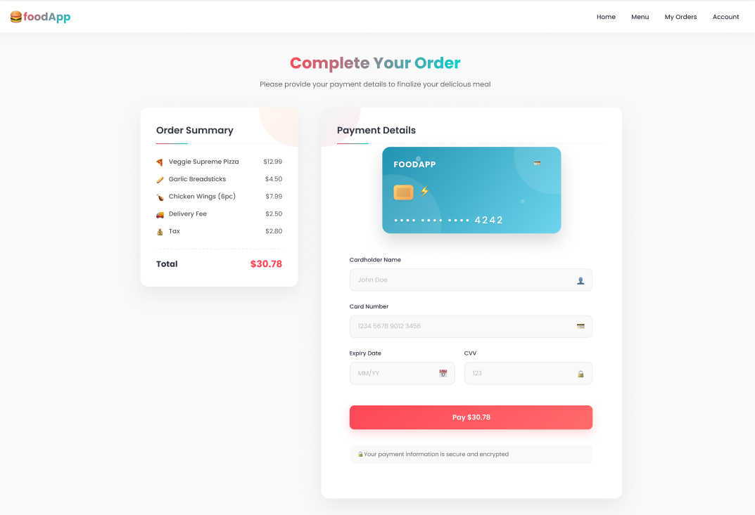

Video Link

https://drive.google.com/file/d/1sLkSALc14HB3SNsENVlt4jXgwm3KfYj3/view?usp=sharing

